Heritage at Risk:
Revive, Resist, Reimagine.
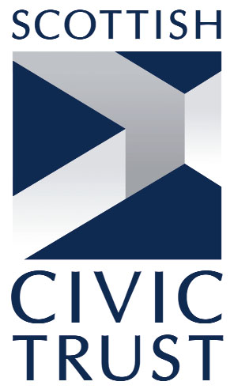
The 2026 shared European Heritage Days theme is Heritage at Risk: Revive, Resist, Reimagine. This theme raises awareness of the various risks threatening our heritage – from a combination of environmental, social, and technological pressures – and encourages reflection on how we can safeguard and cherish what remains. This year’s theme also brings attention to the importance of intergenerational knowledge, the resilience of oral storytelling, and the power of cultural expression in times of crisis.
The 2026 theme Heritage at Risk: Revive, Resist, Reimagine reflects the urgent need for action and creativity in protecting our shared heritage. Revive highlights efforts to bring endangered traditions, sites, and stories back to life – through craft workshops, oral history projects, and cultural festivals. Resist speaks to communities standing up against threats like climate change, conflict, and overdevelopment, using heritage as a source of identity, resilience, and advocacy. Reimagine encourages new ways of engaging with heritage – digitally, artistically, or across cultures – to ensure it remains meaningful, accessible, and alive for future generations.
Heritage at Risk reminds us that our heritage is not static – it is a living, evolving part of who we are. By protecting it today, we ensure that future generations continue to be inspired, informed, and connected through the stories of the past. Together, let us celebrate and protect our heritage – not just as relics, but as guiding stories for our future.
Event ideas are suggested under the following sub-themes: climate change and heritage; digitization and intangible heritage; migration, conflict, and heritage; urbanization and development; intangible heritage: traditions and practices; linguistic heritage: voices at risk; raising awareness and engaging communities; cross-cultural collaboration; and creative approaches.
More information about the theme and event ideas can be found in the brochure.

