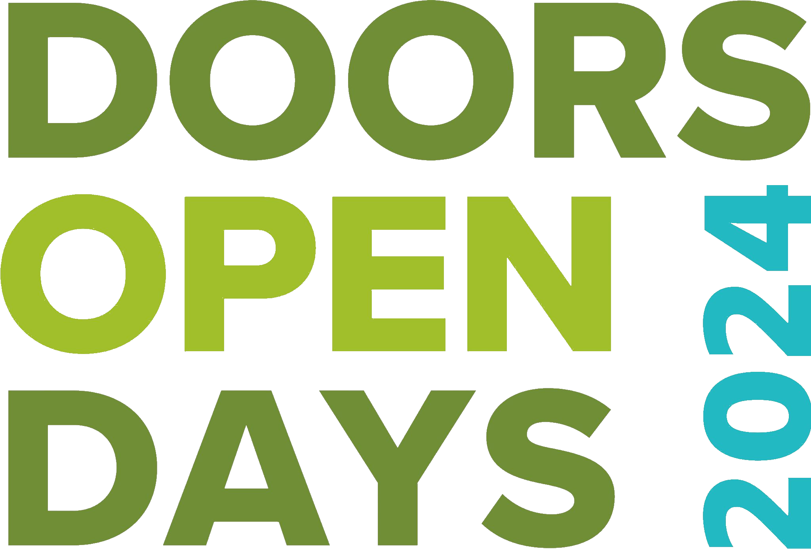

Doors Open Days 2024
Insurance advice for venues hosting an in person event

Venues that want to open their doors and welcome in person visits will have to ensure that they have their own Public Liability Insurance (PLI).

Does my venue need Public Liability Insurance?
Public liability insurance is about physical harm, so if you are opening up as a venue that will welcome actual physical visitors, then you will need to ensure you have your own Public Liability Insurance. If you are only delivering digital content via a website or an online platform, then you do not need to take out Public Liability Insurance, because you will have no physical visitors to your venue.

What do the venues that are physically opening need to do?
You should discuss with your own insurers the type of cover you need, and you should let them know that you are inviting free visitors into your venue as part of Doors Open Days.

Does every venue have to fill in a risk assessment?
The named people/organisations/events are responsible for their own guided tours, events, activities, injuries etc., which is why venues opening must have their own Public Liability Insurance in place.

Scottish Civic Trust, the national organiser for Doors Open Days, suggests it is best practice to always fill in a risk assessment for your venue. The form on the Doors Open Days website is an example, and your venue can take the template and amend for their purposes, or they may already have a suitable risk assessment in place.

For more information or if you are leading a walk/tour and would like to become a Scottish Civic Trust volunteer for the duration of your activity, please contact us at dod@scottishcivictrust.org.uk.

