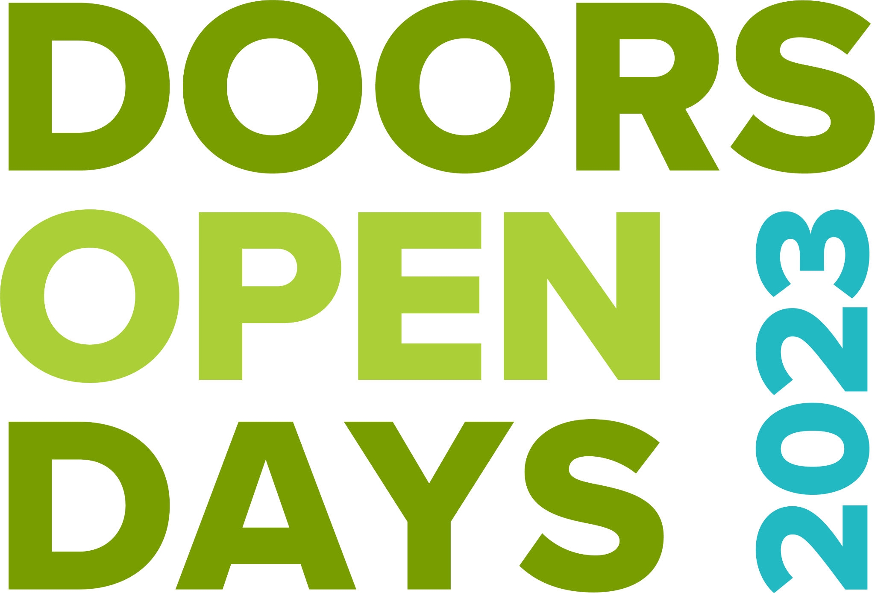
DOORS OPEN DAYS RISK ASSESSMENT GUIDE
This guide will show how to complete a Risk Assessment. We recommend that you fill out a risk assessment for the safety of your staff, visitors, and property. If a claim against the insurance policy is made, a completed risk assessment will demonstrate that precautions were taken to reduce the risk of an incident occurring.
What is a risk assessment?
A risk assessment is a careful examination of what could cause harm to people, which enables you to consider whether you have taken precautions or should do something to prevent harm. The aim of any risk assessment is to identify risks and take suitable measures to minimise the likelihood of any harm or damage occurring.
Why carry out a risk assessment?
Everyone who organises events or manages places that welcomes members of the public can use a risk assessment to anticipate, monitor and control potential risks.
Employers are legally required to assess and take action to minimise risks to the health, safety, and welfare of their employees at work as well as people not in their employment, including customers, visitors, volunteers, or contractors.
As a Doors Open Days organiser who volunteers to open a building or stage an activity, you may not be legally bound to carry out a risk assessment before the event. However, it is highly likely that the insurer of your property or activity will ask you to do so and will certainly want to see proof of it in case an accident occurs.
We strongly recommend doing a risk assessment of your property or planned activities before an event. Examining and preventing risk is the right thing to do. It may take up a little time now but it will certainly give you peace of mind, and it may spare you a lot of work later. Remember to communicate the results of your report to everyone working or volunteering for your event. It will remind people of the possibility of particular risks on the day and of precautionary action they can take.
Hazards vs Risks
Hazard = something with the potential to cause harm
Risk = the likelihood and the severity of the harm
For example, a wet and slippery surface could clearly be a hazard that could potentially lead to injury. The risk is that passers-by slip and fall, hurting themselves.

Things to address and consider in your risk assessment:
- While not legally required it is still strongly recommended that you continue to consider COVID-19 as part of your procedures: https://www.gov.scot/publications/coronavirus-covid-19-general-guidance-for-safer-workplaces/pages/overview/
- This is a voluntary tool which can be used to undertake a regular self-assessment of the measures you have in place to reduce the risk of transmission of COVID-19 in your venue: https://www.gov.scot/publications/coronavirus-covid-19-general-guidance-for-safer-workplaces/documents/
- What is the venue or event capacity? Why not use a capacity calculator to work out how many people can be in your space at one time: capacity-party-space-calculator

Delivery checklist
- Venue: tell your insurer that you are taking part in Doors Open Days and tell them as many details as possible – date, capacity, risks etc
- Walk leader: register your event with the regional coordinator, and take part in Scottish Civic Trust volunteer training
- Before the event day: Fill in a risk assessment
- Before the event day: Share the risk assessment with your team and staff, and make plans to implement all the precautions
- On the event day: check that all precautions are in place, and no new risks or hazards need be added
- After your event day: review the risk assessment and note any changes for future years, and file for future reference

Attached are a few examples of risk assessment forms and a blank form to complete. If you have any questions please email dod@scottishcivictrust.org.uk.

Doors Open Days: Sample Risk Assessment 1
Event to be assessed: Visit to a historic church Date of Assessment: 10th August 2020

Name of assessor: Anne Organiser Organisation: Church volunteers
Activity / process / occupation | Step 1  What hazards to health and/or safety exist? |  | Step 2  What risks do they pose to volunteers/staff and visitors? |  | Step 3a  Precautions already taken? |  | Step 3b  Risk level achieved?  (High, Med, Low) |  | Step 4  Are additional measures necessary?
Members of the public visiting a church, including rooms not normally open to the public. Exhibition in back room. |  | - Trip hazards: uneven ground by entrance  - Narrow passage leading to back rooms where exhibition is being held.  - Broken step further along passage |  | - Members of the public may trip on the uneven ground or where the tarmac changes to rough ground.  - Overcrowding in back room and along passage leading to accidents.  - Member of the public could trip |  | - Guides informed of rough ground and lighting. Lighting to be switched on in advance of tour group’s arrival.  - Numbers restricted to 25 at any one time.  - Door locked to prevent access (fire exits not affected) |  | M  L  L |  | - ‘Welcome’ steward to warn members of the public and a sign placed by rough ground.  - Steward in back room will monitor visitor numbers and restrict access where necessary.  - None needed

Doors Open Days: Sample Risk Assessment 2
Event to be assessed: Walking Tour in City Centre Date of Assessment: 15 May 2015

Name of assessor: Sarah Organiser Organisation: Heritage volunteers
Activity / process / occupation | Step 1  What hazards to health and/or safety exist? |  | Step 2  What risks do they pose to volunteers/staff and visitors? |  | Step 3a  Precautions already taken? |  | Step 3b  Risk level achieved?  (High, Med, Low) |  | Step 4  Are additional measures necessary?
Walking tour around the city. Stopping at points of interest. |  | - Trip hazards: uneven ground along the way  - Busy Roads  - Long Walk may be Strenuous  - Distancing of group members |  | - Members of the public may trip on the uneven ground.  - Members of the public may be hit by a vehicle if not paying attention.  - Member of the public may push themselves  - Members of the tour are too close to each other according to social distancing guidelines |  | - Check the route and avoid any severe hazards.  - Select roads that are less busy, select times that at less busy and use pedestrian crossings where possible.  - Note how strenuous the walk will be in the programme.  - Limit numbers on the walk; remind tour members to keep distance from others; take names and addresses of all tour attendees for test and project purposes |  | M  H  L  M |  | - ‘Welcome’ to warn members of the public and advise them to be careful. Highlight any hazards on the way.  - Only speak to the group when all members of the public are in a safe gathering space. Do not speak when crossing roads.  - Keep an eye on all members of the public and slow the walk down or take a break if necessary.  - Keep an eye on walk member and slow down as necessary; remind everyone at the start of the walk to keep distances and pause if necessary to allow flow and space
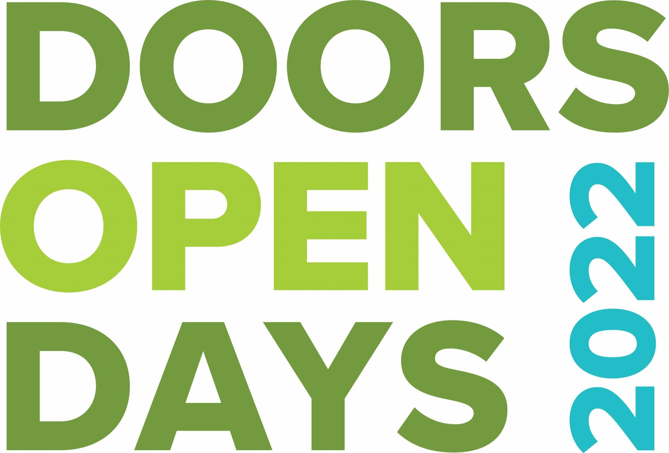

Doors Open Days: Risk Assessment Form

Event to be assessed: Date of Assessment:

Name of assessor: Organisation:
Activity / process / occupation | Step 1  What hazards to health and/or safety exist? | Step 2  What risks do they pose to volunteers/staff and visitors? | Step 3a  Precautions already taken? | Step 3b  Risk level achieved?  (High, Med, Low) | Step 4  Are additional measures necessary?

REMEMBER: Before an event or activity, remember to inform volunteers and staff of the hazards you have identified and the measures you have taken to control potential risks.
Keep this record of your assessment for future reference. It will remind you and others of particular hazards and precautions and will help in any insurance case.

